Looking for Fun, Great Music, Physical and Mental Fitness? Try Square Dance Lessons! First night FREE.
Three Introductory Sessions on Tuesdays 7-9 PM… February 6th; February 13th; February 20th, 2018
(After your First Night, $5 Per Person. Regular classes start February 27, 2018)

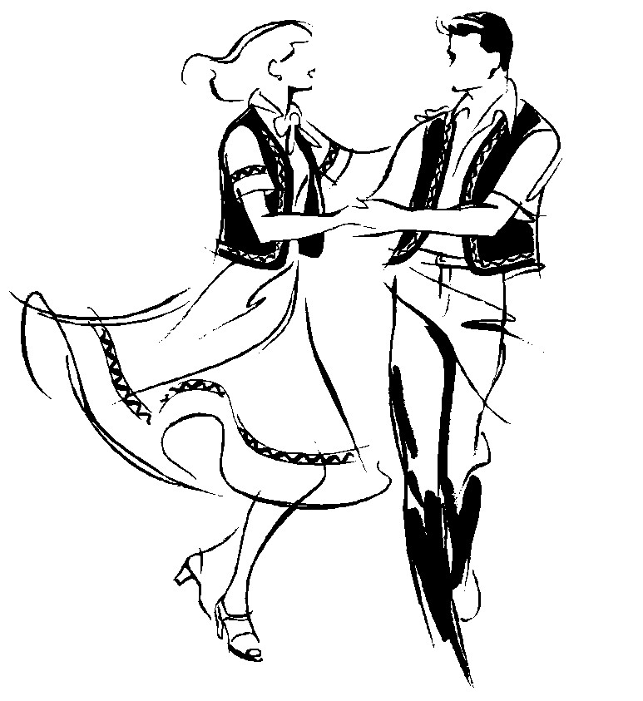
Rainbow Squares http://rainbowsquares.club/
Milmay Fire Hall (Best wood dance floor in South Jersey.)
225 Broad Street (Rt. 552) near the intersection with Rt. 557.
Milmay, NJ 08340
Couples, Singles & Families welcome! Info. 609-839-3796
Grab a Partner & Come!
609 609 609 609 609 609 609
839 839 839 839 839 839 839
3796 3796 3796 3796 3796 3796 3796
web site: web site: web site: web site: web site: web site: web site:
rainbowsquares.club rainbowsquares.club rainbowsquares.club rainbowsquares.club rainbowsquares.club rainbowsquares.club rainbowsquares.club

